Notes from South FLAGs Admin Referee
Coaches,

FLAGs is rapidly approaching, and our goal is to run an efficient meet that supports our swimmers and allows them to focus on swimming fast. I have a few things to note so we are all on the same page.

Positive check-in and scratches will be done on paper at the Admin Table. Remember Thursday’s events are POSITIVE CHECK IN (ie- if you fail to check-in your swimmers will NOT be swimming). Friday, Saturday and Sunday events are Prelim SCRATCH events (ie- we are assuming you swimmer WILL swim unless we are told otherwise, if they are not scratched and they do not swim, they will be penalized). The scratch book for finals events will be supervised.

POSITIVE CHECK INs:

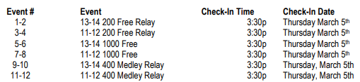

SCRATCH DEADLINES:

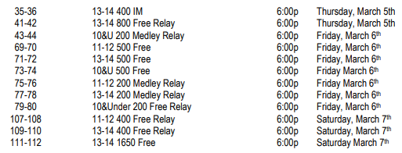
Announcement reminders will be put out over the PA, but please try to get your swimmers check in early. If a swimmer is not checked in and the deadline is past, there is a chance that your swimmer will not be seeded. If you notice this happens, please see me and if there is an open lane we will get them in. There will not be any new heats created due to a swimmer not being checked in.

Scratch Table:
We will have Scratch Books (1 for each Boys and Girls) manned and supervised, at the admin table. When you or your swimmers decide to Scratch from a final, please only use a single line through the name and place your initial there as well. We will be asking swimmers if their Coach is aware of the scratch, before we allow them to scratch their name.

Text Scratches: While using the scratch book is preferred, I will give Coaches the option to send a text to (571) 205-0838 to scratch.
You must include: Your Name, Your Email, Team, Swimmers Name, Event Number and your intention (Scratch or intend to scratch).

If you do not receive a confirmation text, the scratch has not been received. It is your responsibility to text again and receive confirmation. Coming to the Admin table saying you scratched via text will not be an acceptable excuse for a missed final heat. We will have a log of all text messages received and sent on record.

Sunday Scratches:
We are asking that anyone that swims on Sunday and you know you are not going to return for Finals, please scratch. This will allow others a chance to swim and avoid any delays or confusion. There have been times that a swimmer placed 37th in prelims and on Sunday was scratched into finals.

Scratch Penalty:
- No penalty for scratching on the blocks in prelims except for individual positive check-in deck seeded events.
  - Swimmers entered and checked in for a deck seeded event must swim that event. Failure to do so will result in the swimmer being barred from his/her next individual event on that day or the next, whichever is first (excluding finals or relay swims)
- Any swimmer who competes in a preliminary heat and qualifies as one of the original 16 finalists must swim in that final's event; or must notify the Admin Ref that he/she intends to scratch from that final's event within 30 minutes of the announcement of the qualifiers.
- Swimmers may reverse their intention to scratch and choose to be seeded for finals if they do so within 30 minutes of the conclusion of the preliminary session for that day.
  - Any swimmer in a championship or consolation final who fails to swim that event will be barred from their next individual event, excluding finals and relays, in which he/she is entered unless excused by the meet referee.
  - A swimmer not originally qualified for the championship or consolation final that is seeded into a final due to a scratch of another swimmer will not be penalized for failing to swim in that final.
**Note** If you become aware that a swimmer is not going to be present for finals, please notify the Meet Referee and/or Admin Referee at or before the start of Finals warm-up so that we can try to make alternates aware in advance.

Fine:
- Clubs with swimmers that fail to swim in Finals on Sunday night without Scratching will incur a $100 Club Fine per event.

Distance:
- 1000 will be swum fastest to slowest by event
- 1650: fastest heats of boys and girls will be with finals. The remainder will be swum fast to slow, alternating heats of girls/boys

Relay Cards:
- Relay cards will be available prior to the start of each session
- Please fill out the card and return it to the admin table. Do not send the card with your swimmers to the blocks
- If you need to make a change after turning in the cards, just notify the admin table and we will correct the name on the relay card
All the best, and may the swimmers swim fast and enjoy FLAGs, Nathan Dean
Admin Referee
Florida Swimming 2026 FLAGs South
ndean75@gmail.com
Text - (571)205-0838

